## Cloning and Forking

Created Github Repository by forking an already created Repo. I then modified the fork into my own

<https://github.com/JoseModi97/HTML-Gretting-Started-With.git>

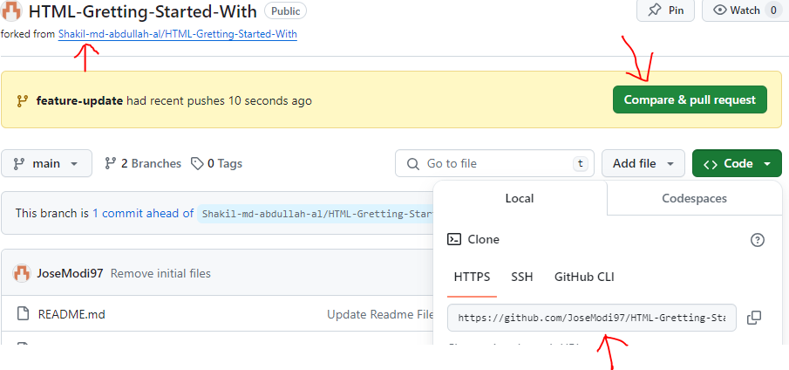

I have downloaded the project to my pc through git clone

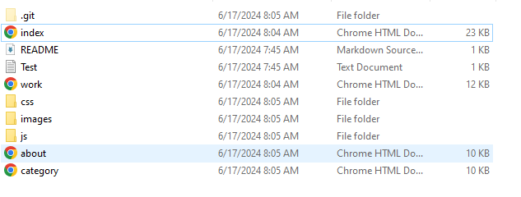

## Managing Branches

I then created a new branch called `feature-update` and added the already created html files that resulted in github indicating that a pull request is pending. I am using github desktop that automates all git and github processes like git checkout, creating of branches, among others.



 Making Changes and Committing:



Merging changes



Conflict1 is a commit in feature update branch whereas Conflict 2 is a commit in main branch. We want to merge these two branches

I have created a conflict that has to be sorted before the merge is executed:

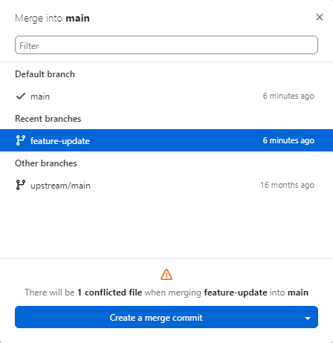

## Handling Conflicts

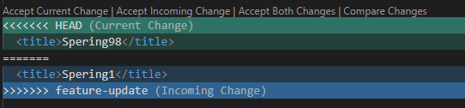

## Resolving Conflicts

**I Accepted incoming change and saved the file**

**After realizing that there are no longer any other conflicts, I just clicked merge button**

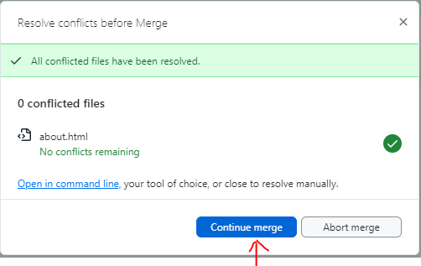

**The next step was to click on push origin:**

